Q1. Why is it difficult to construct a true shared-memory computer? What is the minimum number of switches for connecting p processors to shared memory with b words (where each word can be accessed independently)?
Let's tackle your question carefully and step by step.

Q1(a): Why is it difficult to construct a true shared-memory computer?
A true shared-memory computer is a system where multiple processors can directly access the same memory locations as if there were a single memory. While conceptually simple, there are several practical difficulties:
- Memory Access Conflicts
  - If two or more processors try to read/write the same memory location simultaneously, we need arbitration to prevent conflicts.
  - High contention can severely reduce performance.
- Scalability Issues
  - As the number of processors increases, the bus or interconnection network connecting processors to memory becomes a bottleneck.
  - The memory access time can increase, making the system inefficient for many processors.
- Synchronization Overhead
  - To ensure correct execution, processors need locks or semaphores. Managing these across many processors is complex and can lead to deadlocks or delays.
- Hardware Complexity
  - Each processor needs mechanisms to detect data hazards, manage caches coherently, and handle concurrent memory requests.
  - Designing such interconnection networks (e.g., crossbars, multistage switches) is expensive and complex.
✅ In short: The difficulty arises from contention, synchronization, and the need for scalable hardware to allow simultaneous access.

Q1(b): Minimum number of switches to connect p processors to b memory words
We are essentially looking at memory interconnection networks.
- Direct connection approach:
  - If each processor can independently access any memory word, we need some network that connects p processors to b memory modules.
- Crossbar switch:
  - The simplest theoretical solution is a full crossbar, where each processor has a dedicated path to each memory word.
  - Number of switches required:
Number of switches = p x b
- Each processor has b switches (one to each memory word).
- Why this is minimal:
  - Any network allowing simultaneous access to all b words by all p processors requires at least one switch per processor–memory word pair.
  - Using fewer switches would force contention, meaning some processor cannot access some memory independently.

✅ Answer (Summary)
(a) Difficulties in constructing true shared-memory computer:
- Memory access conflicts among processors
- Scalability limitations as processors increase
- Synchronization overhead for correct execution
- Complex and expensive hardware design
(b) Minimum number of switches for p processors and b memory words:
p x b
- This is the number of switches in a full crossbar network, allowing independent access.

If you want, I can also draw a small diagram for p=3 and b=4 to visualize why p × b switches are needed. It makes this concept much easier to understand.

Q2. Consider set of task in parallel computing system. Each task has a known execution time, and they can be executed concurrently. Calculate the average degree of concurrency for the given set of tasks.

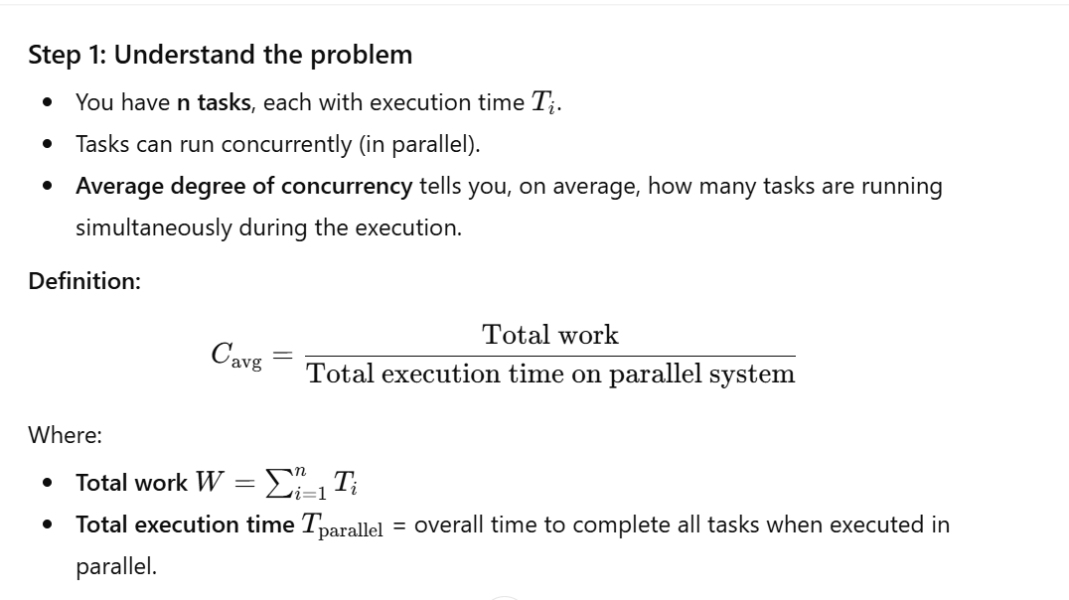 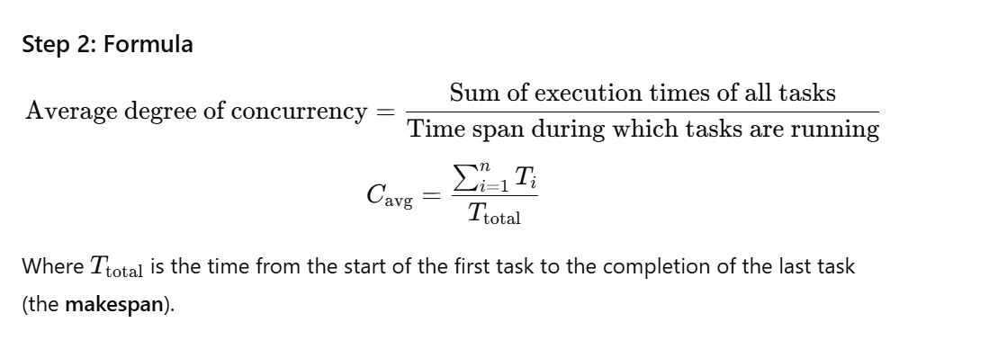 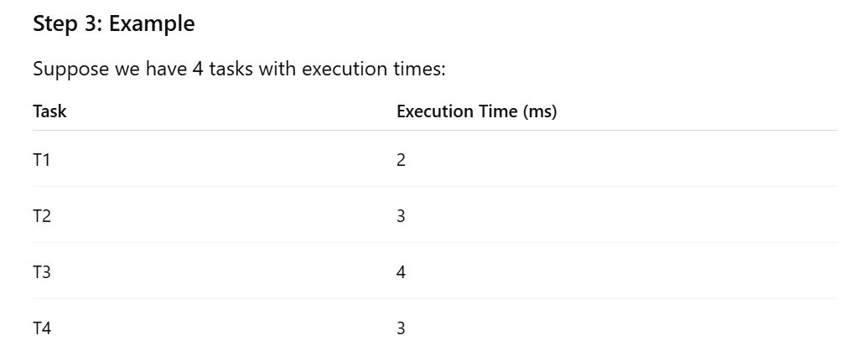 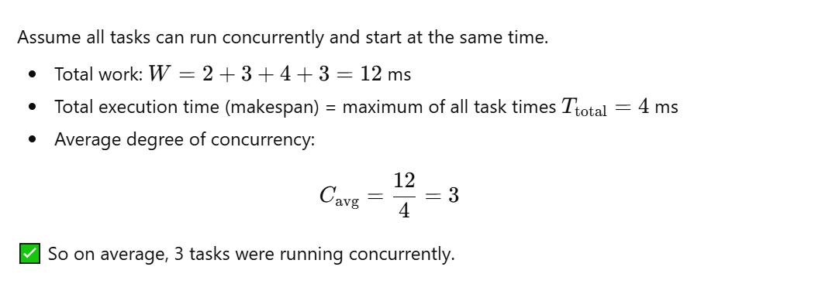 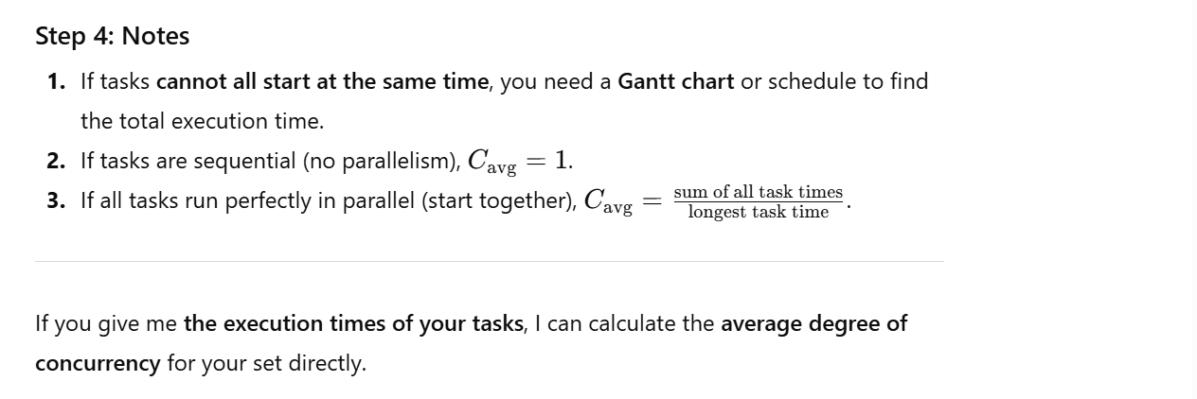 ✅ So, this question is directly related to analyzing task parallelism and concurrency in parallel computing systems, which is part of CLO-3: Analyze complex problems with shared memory programming (OpenMP) and task parallelism.

Q3. Formulate an equestion to calculate the communication cost in a distributed system. Consider factors such as message size, bandwidth and latency.
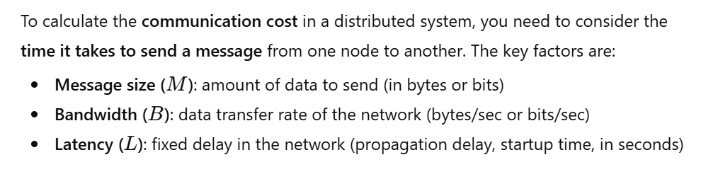 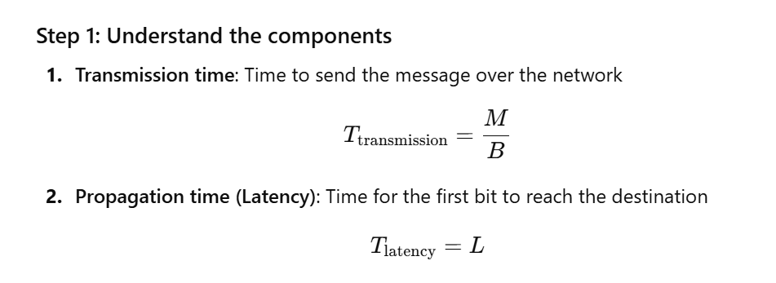 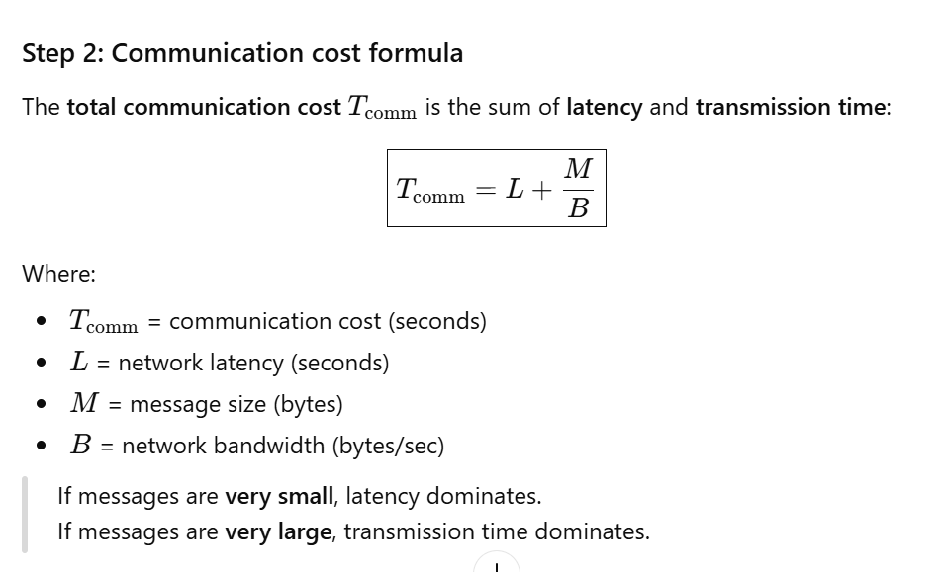 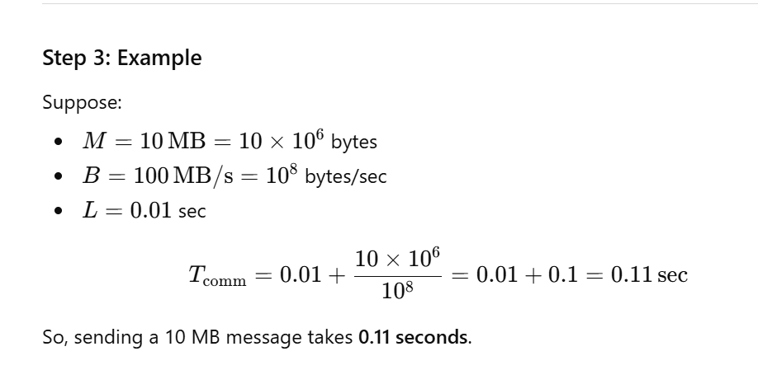 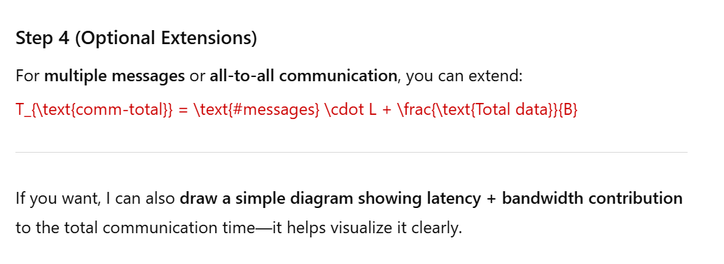 • Mam-extra: Communication Cost in Parallel Machine (lec #6)
• Related sections:
- Asynchronous/synchronous computation/communication (lec #3)
- Basic Communication Operations (lec #14)

Q4. What are criteria that are used to evaluate the cost and performance of static interconnection networks?
In parallel and distributed systems, static interconnection networks are fixed networks that connect processors and memory modules (like buses, meshes, hypercubes, trees, etc.). To evaluate their cost and performance, several criteria are commonly used:

1. Network Diameter
- Definition: The maximum number of hops a message must traverse between any two nodes in the network.
- Impact: Smaller diameters → lower latency → better performance.
- Example: A fully connected network has diameter 1; a linear array has diameter (p-1) for (p) nodes.

2. Bisection Width (Bisection Bandwidth)
- Definition: The minimum number of links that must be cut to partition the network into two equal halves.
- Impact: Larger bisection width → higher potential bandwidth → better communication performance for large-scale parallel tasks.

3. Network Cost
- Definition: Typically measured as the total number of links (or switches) required to build the network.
- Impact: Fewer links → cheaper hardware cost; more links → higher cost but often better performance.

4. Node Degree
- Definition: Number of direct links connected to a node.
- Impact: Lower node degree → cheaper and simpler nodes; higher node degree → better connectivity and lower communication latency.

5. Average Distance (Average Hop Count)
- Definition: Average number of hops a message travels between all pairs of nodes.
- Impact: Lower average distance → lower average communication latency.

6. Scalability
- Definition: How easily the network can grow when more nodes are added.
- Impact: Networks with poor scalability become inefficient or expensive as the system grows.

7. Fault Tolerance / Reliability
- Definition: The ability of the network to continue functioning if some nodes or links fail.
- Impact: Networks with redundant paths can tolerate failures better.

8. Congestion / Throughput
- Definition: Measures how well the network handles simultaneous communication requests.
- Impact: High throughput → better performance for parallel tasks; congestion can cause delays.

Summary Table:
Criterion | Importance
Network Diameter | Latency between farthest nodes
Bisection Width | Maximum simultaneous communication
Network Cost | Hardware expense
Node Degree | Complexity & cost per node
Average Distance | Average message delay
Scalability | Ease of expansion
Fault Tolerance | Reliability under failures
Congestion / Throughput | Efficiency under heavy traffic

These criteria help designers balance cost vs. performance when choosing or designing static interconnection networks.
“Interconnection Networks in Parallel and Distributed Systems” or more specifically:
- Clg-5: Heterogeneity, Interconnection Topologies (lec #8)
- Related topics:
  - Network performance analysis (diameter, bisection width, throughput)
  - Scalability and cost evaluation of network designs

Q5. Define cloud computing and explain its essential characteristic. Also explain the primary security challenges in cloud computing.

Definition of Cloud Computing
Cloud computing is a model for delivering computing services—such as servers, storage, databases, networking, software, and analytics—over the internet (“the cloud”). It allows users to access and use resources on-demand without owning or managing the underlying infrastructure.
Formal definition (NIST):
“Cloud computing is a model for enabling ubiquitous, convenient, on-demand network access to a shared pool of configurable computing resources (e.g., networks, servers, storage, applications, and services) that can be rapidly provisioned and released with minimal management effort or service provider interaction.”

Essential Characteristics of Cloud Computing
- On-Demand Self-Service:
  - Users can provision computing resources automatically as needed without human interaction from the service provider.
- Broad Network Access:
  - Services are available over the network and can be accessed via standard devices like laptops, smartphones, or tablets.
- Resource Pooling (Multi-Tenancy):
  - Cloud providers serve multiple customers using shared physical and virtual resources, dynamically allocating according to demand.
- Rapid Elasticity:
  - Resources can be scaled up or down quickly to handle workload changes, giving the appearance of unlimited resources.
- Measured Service (Pay-per-Use):
  - Resource usage is monitored, controlled, and reported, allowing users to pay only for what they consume.

Primary Security Challenges in Cloud Computing
- Data Breaches and Loss:
  - Unauthorized access or accidental deletion of sensitive data stored in the cloud.
- Insider Threats:
  - Malicious or careless insiders at the cloud provider or client organization can compromise data security.
- Data Privacy and Compliance:
  - Ensuring that stored and processed data complies with legal and regulatory requirements (e.g., GDPR).
- Account Hijacking:
  - Attackers stealing user credentials to access cloud services, manipulate data, or launch attacks.
- Insecure APIs and Interfaces:
  - Vulnerabilities in cloud APIs or management interfaces can be exploited to gain unauthorized access.
- Denial of Service (DoS) Attacks:
  - Cloud services may be disrupted, affecting availability and performance.
- Shared Technology Vulnerabilities:
  - Multi-tenant environments may expose vulnerabilities in hypervisors, containers, or virtual networks.
- Data Location and Transfer Risks:
  - Data may traverse or reside in different geographical locations, potentially exposing it to legal or security issues.

Summary Table:
Aspect | Details
Definition | On-demand delivery of computing resources via the internet
Essential Characteristics | On-demand self-service, broad network access, resource pooling, rapid elasticity, measured service
Primary Security Challenges | Data breaches, insider threats, privacy/compliance, account hijacking, insecure APIs, DoS attacks, shared tech vulnerabilities

If you want, I can also draw a simple diagram showing cloud characteristics and threats for easier understanding and exam use.
• Course Description: “Cloud and Distributed Tools” (like AWS, OpenStack, Hadoop, Globus)
• Clg-15: Tools (lec #22–#26)
• Concepts include cloud definition, characteristics, service models (IaaS, PaaS, SaaS), and security challenges.

Q6. What is difference between virtualization and containerization in cloud computing?

1. Virtualization
- Definition: Virtualization is the process of creating virtual instances of hardware (virtual machines) on a single physical server using a hypervisor. Each VM includes its own OS, libraries, and applications.
- Key Features:
  - Each VM is isolated from others.
  - VMs are heavier because they include a full OS.
  - Startup time is slower compared to containers.
- Example: VMware, VirtualBox, Hyper-V.

2. Containerization
- Definition: Containerization is a lightweight method of packaging an application with all its dependencies (libraries, binaries, configurations) but sharing the host OS kernel.
- Key Features:
  - Containers are more lightweight than VMs.
  - Faster startup time.
  - Better resource efficiency because multiple containers can run on the same OS.
  - Provides process-level isolation, not full OS isolation.
- Example: Docker, Kubernetes, LXC.

Comparison Table
Feature | Virtualization (VM) | Containerization
OS Required | Full OS per VM | Shares host OS kernel
Resource Usage | Higher (heavyweight) | Lower (lightweight)
Startup Time | Slower (minutes) | Faster (seconds)
Isolation Level | Hardware-level / OS-level | Process-level
Portability | Moderate | High
Examples | VMware, VirtualBox, Hyper-V | Docker, Kubernetes, LXC

Summary:
- Virtualization emulates hardware and runs multiple OS instances on one physical machine.
- Containerization packages applications with dependencies while sharing the host OS, making it lighter, faster, and more portable.

If you want, I can also draw a simple diagram showing VMs vs Containers for visual clarity—it’s very useful for exams.
• Clg-15: Tools / Cloud and Distributed Tools (lec #22–#26)
• Concepts in cloud architecture: virtualization (VMs) vs containerization (Docker, Kubernetes) for resource management and deployment efficiency.

Q7. How does matrix multiplication work in parallel computing? Explain with an example.

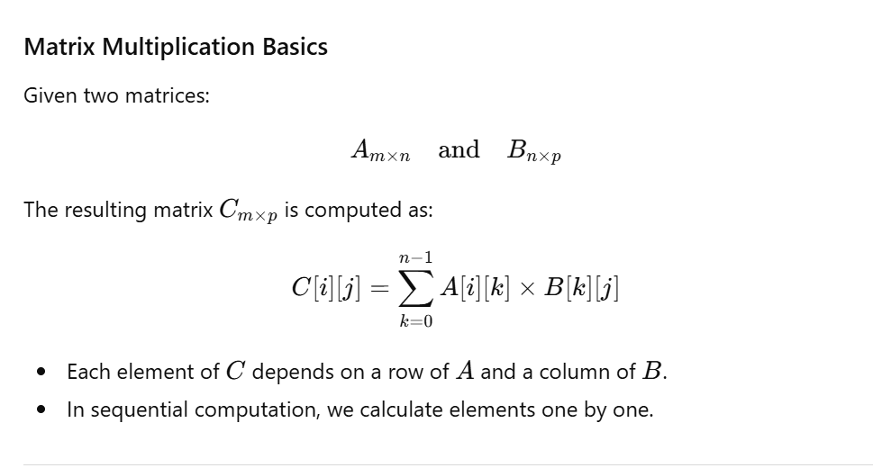 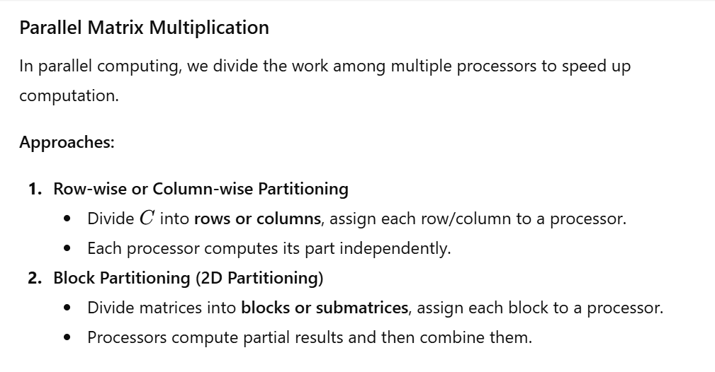 Example: Parallel Row-wise Multiplication
Suppose we have:
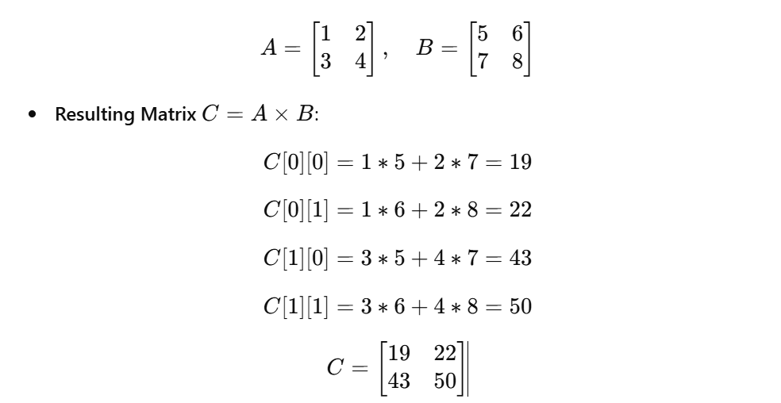 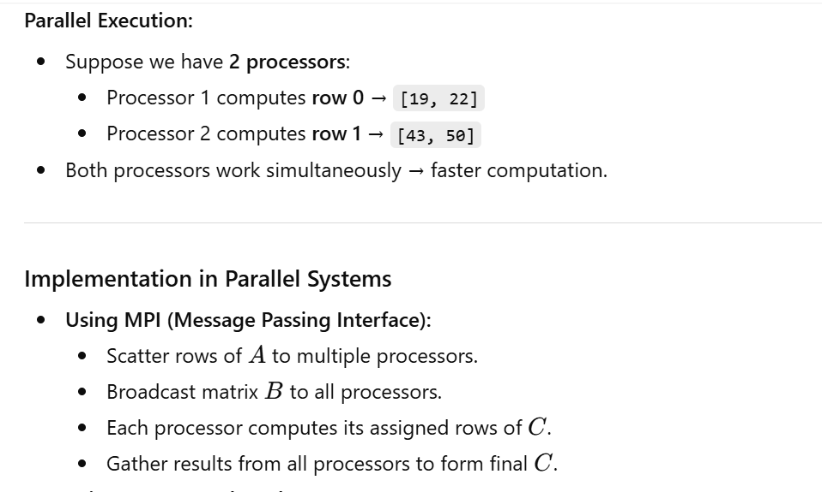 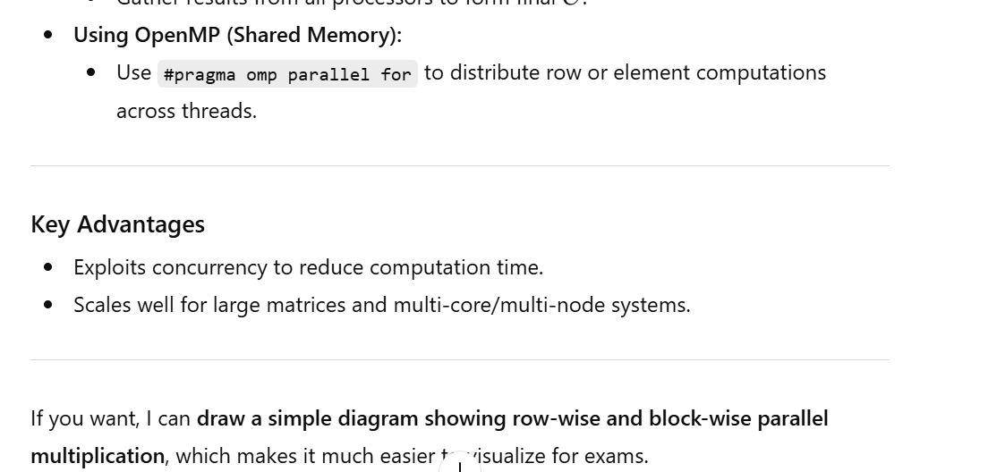 • Clg-10: Multithreaded Programming, Parallel Algorithms & Architectures (parallel algorithm models lec #5)
• Main Coding Areas:
- Message Passing Interface (MPI): distributing rows/blocks of matrices across nodes
- OpenMP / Multithreading: parallel computation of rows/elements

Q8. Explain Dijkstra’s algorithm for shortest paths and how it can be implemented in a distributed system.
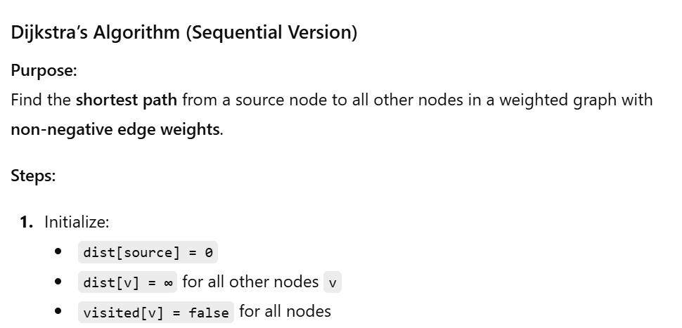 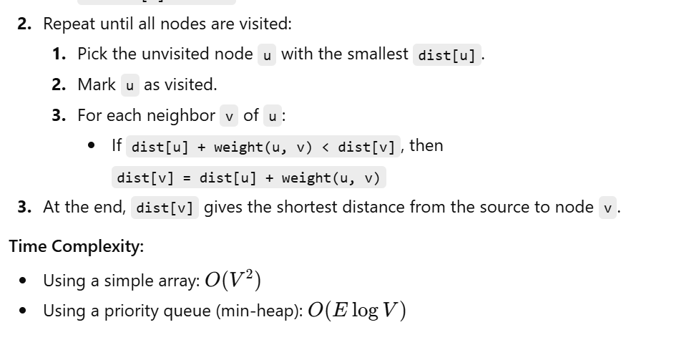 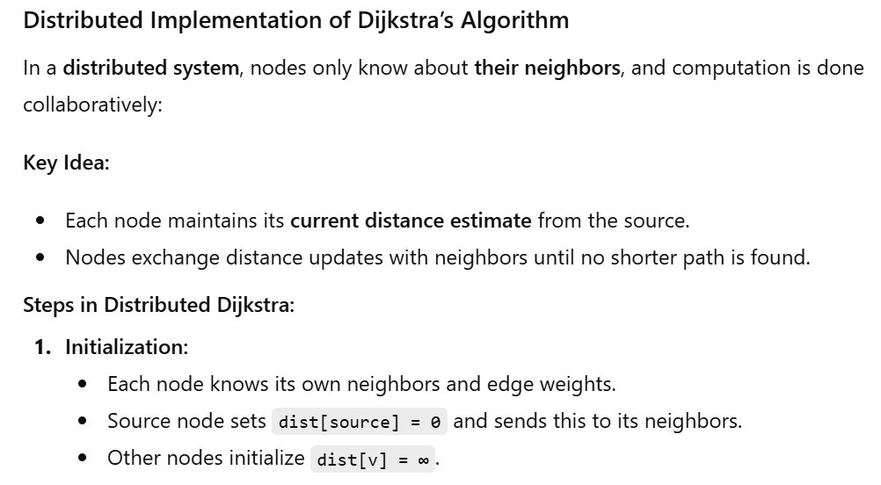 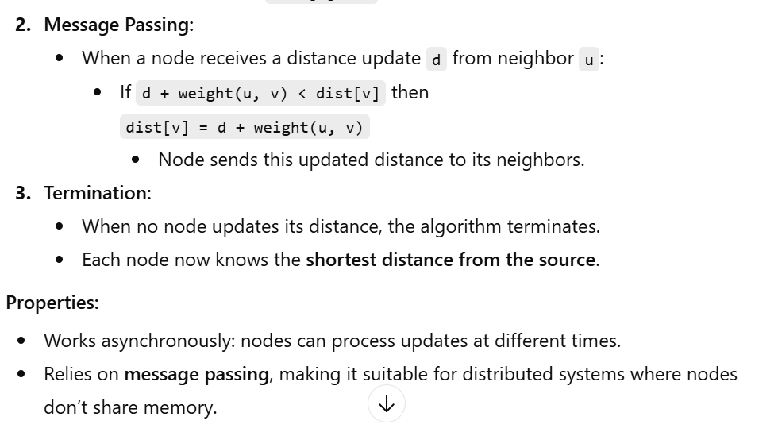 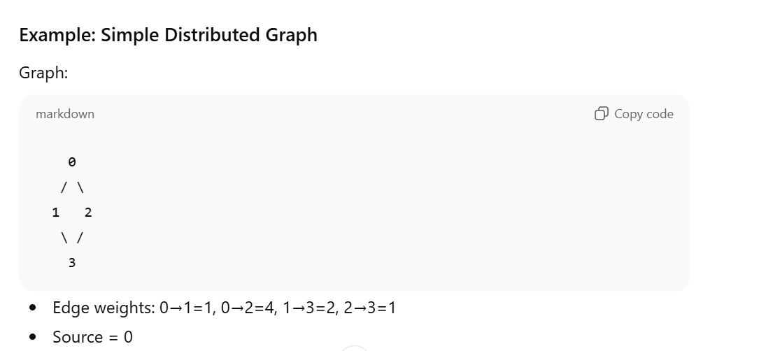 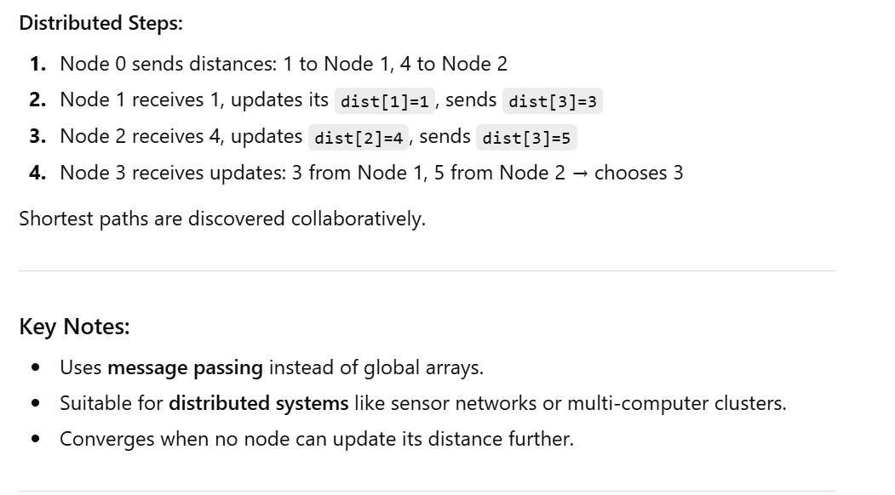 • Clg-11: Basic Communication Operations (lec #14) – because distributed Dijkstra relies on message passing between nodes.
• Parallel Algorithms & Architectures (lec #5 / Clg-10) – understanding how algorithms can be executed collaboratively across multiple nodes.

Q9. Benchmarking a parallel program on 2, …………., 8 processors produces the following speedup results:
No. of processor | 2 | 3 | 4 | 5 | 6 | 7 | 8
(n,p) | 1.87 | 2.61 | 3.23 | 3.73 | 4.14 | 4.46 | 4.71

Determine serial fraction e(n,p) and find the primary reason that is contributing to the poor performance, where (n, p) denotes speed up.
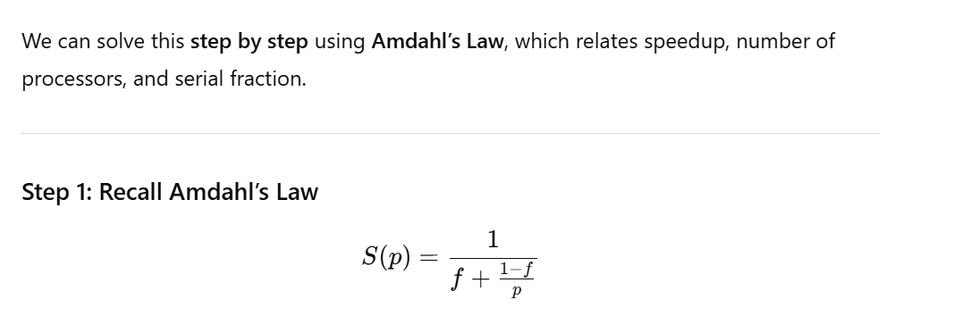 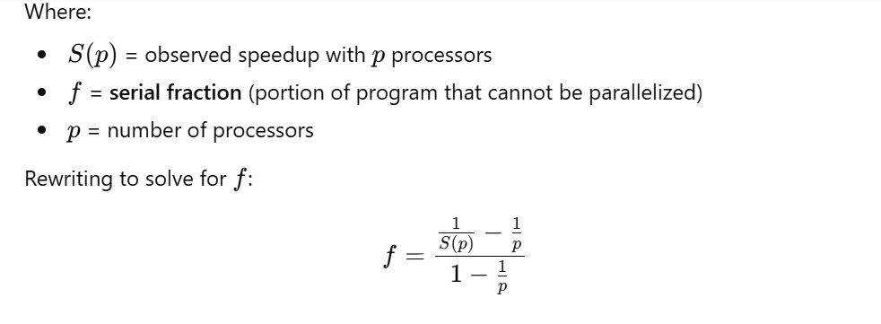 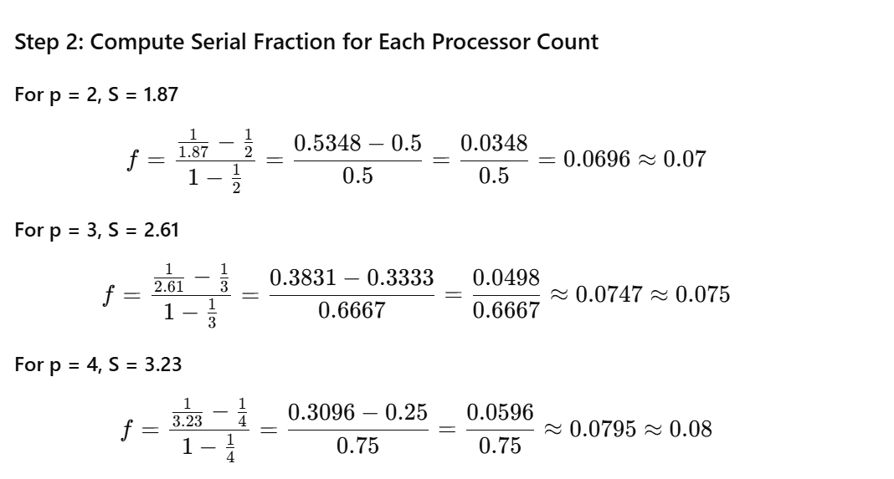 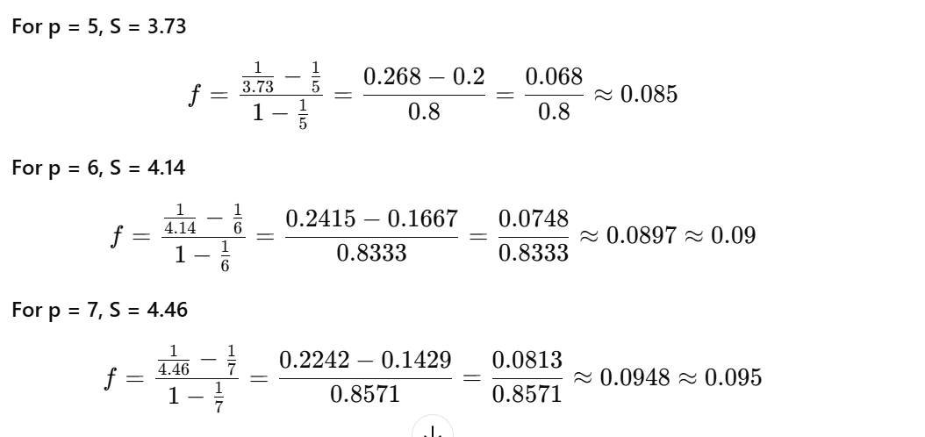 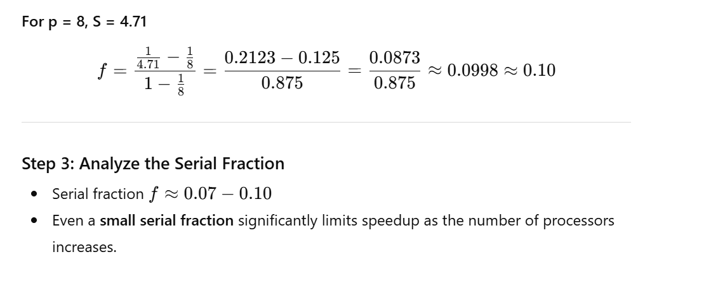 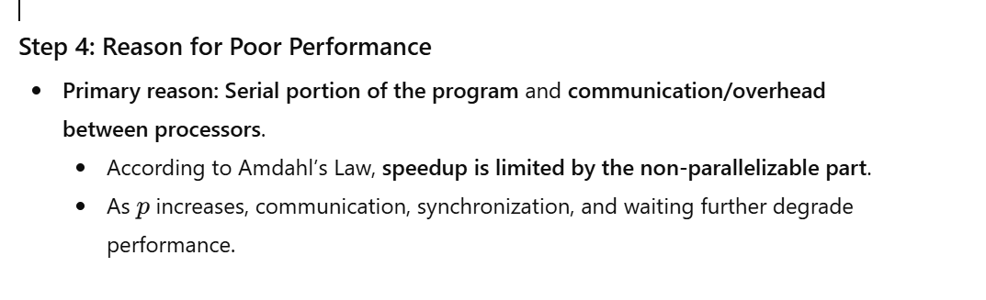 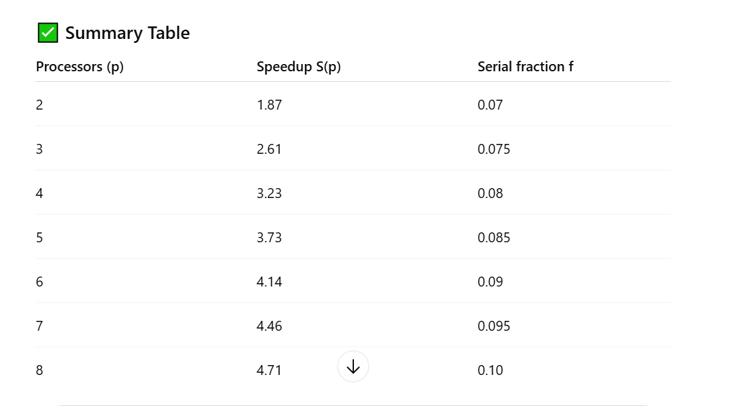 Conclusion:
- Serial fraction and inter-processor overhead limit parallel speedup, causing poor performance as processors increase.
- • Clg-5 / Clg-13: Performance analysis and tuning, scalability and performance studies
- • Concepts covered include speedup, serial fraction, and factors affecting parallel program performance in parallel and distributed computing.

Q10. Suppose you have a program with parallelizable fraction f= 0.8, meaning 80% of the program can be parallelized. Calculate the speedup for the program using Amdahl’s Law for P=1, 2,4 and 8 processors. Also find No. of processors required for maximum speedup.
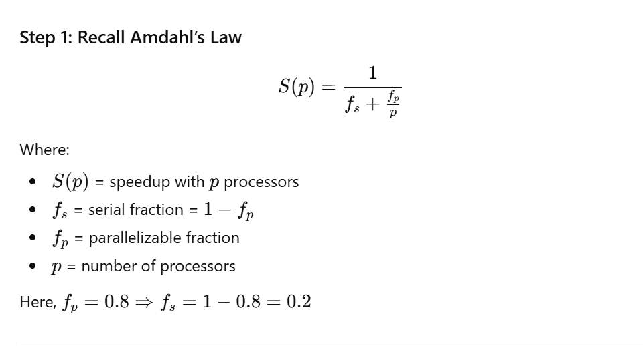 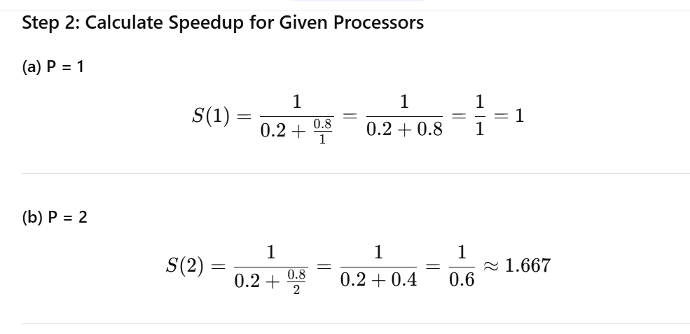 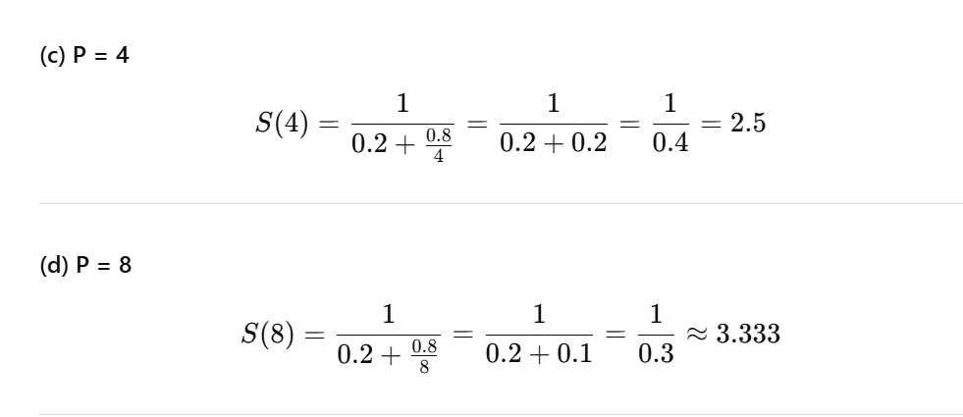 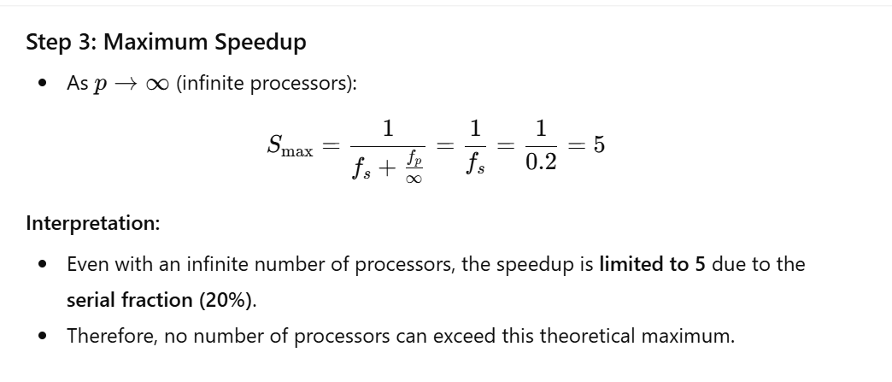 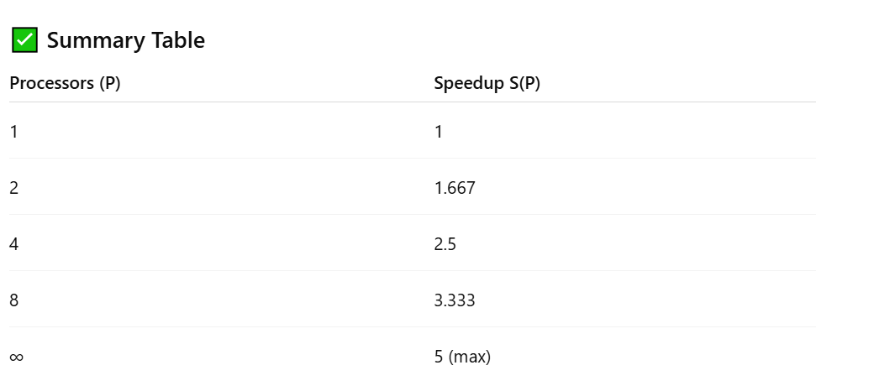 Key Insight:
- The serial portion of the program limits maximum speedup, which is a fundamental concept in parallel computing and performance analysis.

🔹 1️⃣ Most Important Topics (High Focus)
Ye topics exam, coding assignments, aur viva ke liye critical hain.
Topic | Reason | Focus Tips
MPI (Message Passing Interface) | Core distributed programming tool; projects / labs | Example: matrix multiplication, All-to-All broadcast/reduction
OpenMP / Multithreading | Shared memory parallel programming; critical for parallel algorithms | Example: parallel sorting, sum reduction
Parallel Algorithms | Conceptual + coding questions; needed for exam | Practice: merge sort, prefix sum, search algorithms
Performance Analysis & Tuning | Bloom’s Taxonomy: analyze & evaluate parallel programs | Understand speedup, efficiency, Amdahl’s Law
Memory Hierarchies & Consistency Models | Important for reasoning about performance | Focus on read/write ordering, caching issues
Concurrency / Synchronization | Critical for threads and parallel execution | Mutex, semaphore, deadlock, race condition
Task Parallel / Shared vs Distributed Memory | Core concepts; exam questions | Understand difference between multithreading and message-passing
GPU Programming (CUDA) | Modern and impressive; sometimes project/viva question | Focus on kernel basics, threads vs blocks, parallelization
Cloud/Distributed Tools Overview (AWS, Hadoop, OpenStack, Globus, Condor) | Conceptual; exam/project discussion | Don’t memorize everything; focus on purpose/use-case
✅ Tip: MPI + OpenMP + Parallel Algorithms + Performance Analysis = backbone of course.

🔹 2️⃣ Medium Priority Topics (Moderate Focus)
Ye topics conceptually samajhne hain, coding mein kam use hote hain.
Topic | Reason | Focus Tips
Scheduling & Load Balancing | Exam conceptual questions; real-world relevance | Focus on idea, types of scheduling (static vs dynamic)
Interconnection Topologies | Conceptual understanding; exam diagrams | Mesh, Hypercube, Star, Ring – basic properties
Decomposition Techniques | Used in algorithm design | Block, cyclic, recursive decomposition
MIMD / SIMD | Parallel architecture concept | Understand difference & example
Parallel I/O | Occasionally asked in exams | Conceptual: how data read/write happens in parallel systems
Fault Tolerance | Conceptual; may appear in viva | Replication, checkpointing

🔹 3️⃣ Low Priority / Optional Topics (Skip if time is limited)
Ye topics mostly advanced / tools overview — focus only if time permits.
Topic | Reason | Notes
FUSE (Filesystem in Userspace) | Advanced, rare in exams | Skip unless project requires
Swift / Condor / Globus | Distributed toolkits; rarely exam focus | Just know purpose, don’t memorize commands
Amazon AWS / OpenStack | Cloud deployment tools | Conceptual: storage, compute, virtualization
Power / HPC-specific topics | Mostly research-level | Can skip for exam unless directly asked
Extra Lecture #6 Communication Cost | Minor detail | Conceptual understanding enough

🔹 4️⃣ Recommended Study Strategy
- Coding Priority:
  - MPI → 40% focus
  - OpenMP / Threads → 30% focus
  - CUDA / GPU → 10–15% focus
  - Parallel Algorithms → 15% focus
- Conceptual Priority:
  - Shared vs distributed memory → high
  - Synchronization, concurrency → high
  - Performance & scalability → high
  - Cloud tools / advanced toolkits → low unless project needs
- Viva / Exam Tip:
  - Examiner usually focuses on MPI, OpenMP, parallel algorithms, synchronization, and memory.
  - Cloud / Hadoop / AWS / OpenStack = only conceptual questions.

✅ Key Takeaways
- High Focus: MPI, OpenMP, Parallel Algorithms, Concurrency, Memory
- Medium Focus: Scheduling, Load Balancing, MIMD/SIMD, Decomposition, Fault Tolerance
- Low / Optional: FUSE, Swift, Globus, Condor, AWS, OpenStack, Power/HPC

🔹 Coding ka scope in PDC
- MPI Programs (small examples)
  - Jaise matrix addition/multiplication across nodes
  - “Hello World” communication between nodes
- OpenMP / Threads (small examples)
  - Parallel sum, sorting, reduction
  - Loop-level parallelism
- CUDA / GPU (optional/demo)
  - Basic kernels (vector addition, image filter)
- Parallel Algorithm Pseudocode
  - Merge sort, prefix sum, parallel search
  - Mostly exam / assignment level, not production code
- Tool Usage Examples (Cloud / AWS / Hadoop)
  - Conceptual commands
  - MapReduce pseudo-implementation

🔹 Reality check
- Tum full applications nahi likhoge, small programs or demos hi enough hain
- Exam / viva mein mostly conceptual questions + small snippets poochhe jate hain
- Focus should be on:
  - Logic samajhna
  - Parallel execution ka flow
  - Data synchronization / communication

✅ Conclusion
- Large-scale coding / software project nahi hota
- Small demos / assignments sufficient hain
- Agar ye samajh lo, coding tension nahi hogi

